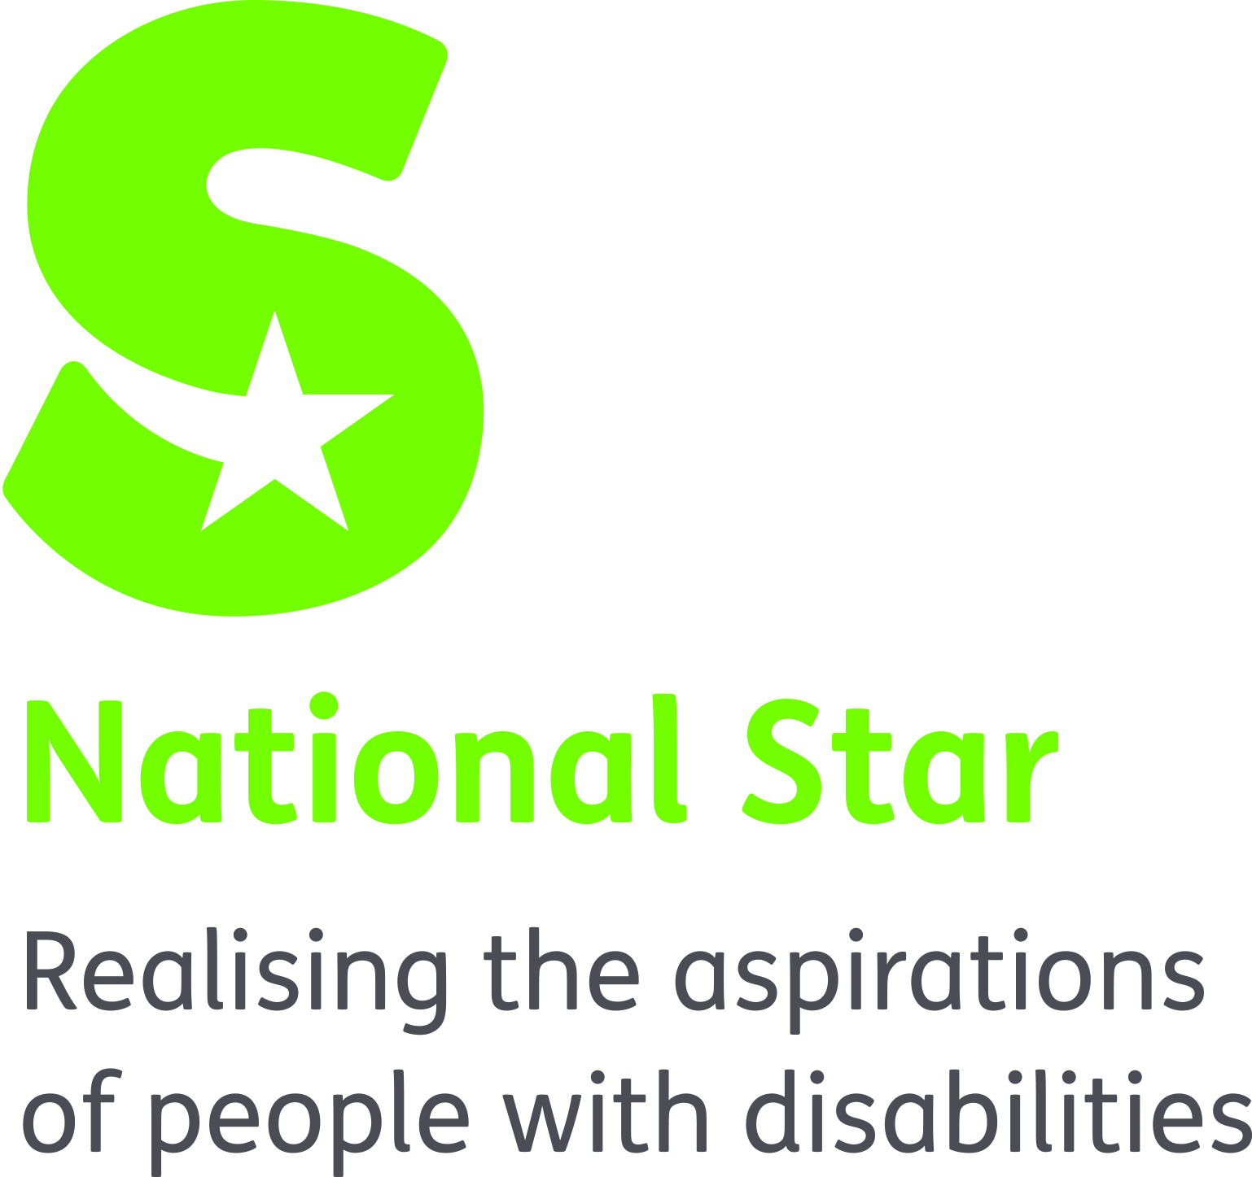

JOB DESCRIPTION
NURSE

ORGANISATION RESPONSIBILITIES:
Reports to: Registered Manager.

MAIN PURPOSE OF JOB:
To deliver the highest standard of individualised health, medical and personal care to residents according to their needs, and to support and train staff in basic healthcare and administration of medication.

PRIMARY TASKS:
- To use up to date knowledge and skills to assess, plan, deliver and evaluate nursing care. With particular support needed for respiratory care.

- To liaise with the Registered Manager, the General Practitioner, the residential team, and other professionals, ensuring appropriate, effective and timely health management for all residents.

- To work in an open and co-operative manner with the residential team, residents and their families, fostering individual’s independence and acknowledging and promoting their involvement in the planning of their care.

- To work in a collaborative and co-operative manner with allied health professionals, and other internal and external agencies involved in providing care and support to the resident.

- To ensure that all documentation and individual records are accurate, complete, and is consistent with legislation, policy and procedures.

- To respond to staff requests for nursing support using triage skills and to manage own time effectively.

- To respond quickly and effectively to individuals who require emergency care.

- To practice safely within all nursing activity including interventions, treatments, and the administration of medication.

- To uphold the National Star policies and procedures in reporting medication errors.

- To participate in quality assurance activities, ensuring medication systems, electronic MAR, and healthcare equipment are managed effectively.

- To support the Registered Manager with all aspects of ordering, storing, administering, and disposing of medication.

- To support individuals to access GP and other healthcare services through referral.

- To participate in the active promotion of independence, incorporating health promotion and education when appropriate, working within your own competency levels.

- Ensure that you keep your knowledge and skills up to date through continuing professional development and ensure all validation requirements are met. To undertake training as required by National Star and to meet NMC requirements.

- To participate in regular clinical supervision in accordance with good practice guidelines and organisational policy.

- To act as an advocate ensuring that the well-being and interests of the resident are safeguarded, ensuring all policies and procedures relating to safeguarding are adhered to.

- To adhere to the organisation’s policy and procedures.

- To provide supervision and observations to staff to ensure their competence to administer medication.

- To share clinical knowledge and experience, and help with development of others.

- To respond to the individual’s complex and changing needs by seeking and improving professional knowledge and competence.

- To work as an integral part of the residential team, alongside facilitators to deliver and promote the highest level of care possible.

- To liaise and work alongside other nursing professionals within the residential setting and within the organisation where appropriate.

- To undertake any other reasonable duties as requested by the National Director of Operations and Head of Services.

SAFEGUARDING
The organisation takes seriously its responsibility for safeguarding and is committed to safeguarding and promoting the welfare of young adults and children. Therefore we require that all staff share this and act accordingly by applying organisation policy and procedure and attending annual safeguarding training.

Equality & Diversity
Through personal example and clear action demonstrate commitment to equality and diversity ensuring equality of access and treatment in employment and service delivery to all.

Health & Safety
Promote National Star’s Health and Safety at Work Policy and Procedure and ensure these are implemented effectively within the department

Person Specification
Nurse – Foundation House Gloucester
ATTRIBUTE | ESSENTIAL | DESIRABLE
Qualifications | Qualified practitioner registered with the NMC | - Teaching qualification  - Post registration certificate/diploma/degree in relevant sphere of practice
Experience | A minimum of:  - Experience of working with people with physical disabilities and associated learning difficulties  - 1 years post registration experience in a relevant/related sphere of practice  - Client caseload management  - Provision of support and guidance to families, carers, nurse colleagues and allied health professionals  - Experience of respiratory care and ideally management of Tracheostomy/Laryngectomy. | - Experience of working in a residential setting
Skills / Knowledge | - Ability to assess, plan, implement and evaluate health programmes without direct supervision and support  - Proactive and creative practitioner  - Recognised as a professional resource to colleagues  - Ability to prioritise, managing complex, diverse and competing client requirement  - Problem solving approach  - Committed to high quality service provision  - Ability to identify own professional development needs and develop a professional portfolio evidencing quality practice | - Specialist knowledge and skills in topics related to scope of practice
Personal | - Good team player  - Effective communicator, written and verbal  - Good interpersonal skills  - Punctual and reliable  - Physically fit to meet the needs of residents.  - Ability to work confidently within a multi-disciplinary team  - requirements of the role  - Client focussed  - Organised and efficient | - Ability to think laterally
Other | - IT literate, able to use Microsoft Office: Word, Excel and PowerPoint  - Support the ethos of the organisation and be fit to work with vulnerable adults. | - Full driving licence

