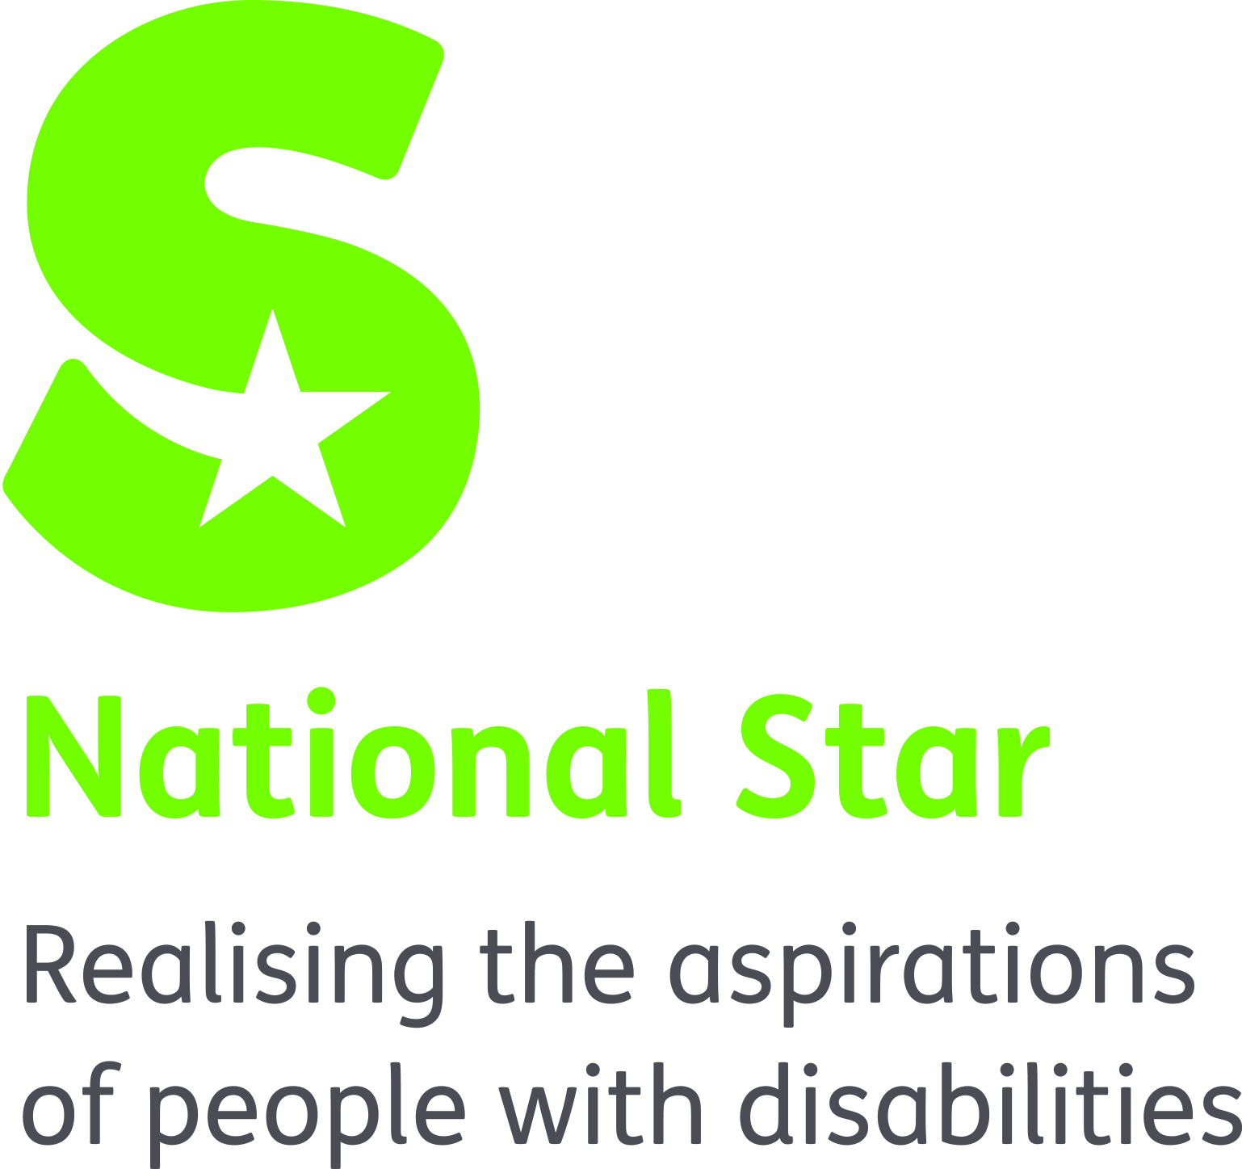

JOB DESCRIPTION
APPRENTICE NURSE

ORGANISATION RESPONSIBILITIES:
Reports to: Head of Health, Care and Support and Clinical Lead Nurse

MAIN PURPOSE OF JOB:
To work in a supported environment to develop the necessary skills and knowledge necessary to complete a Bsc (Hons) Adult or Learning Disability Nursing in partnership with University of Gloucestershire through an apprenticeship scheme. The Apprentice Nurse will work on a supernumerary basis as part of the nursing team under suitable supervision, and within NMC regulations. Under supervision the apprentice will learn and demonstrate competence in a range of nursing skills to be assessed against NMC requirements. The apprentice will undertake a range of placement opportunities both within, and external to National Star. The Apprentice will attend theory modules at the university of Gloucestershire and will be expected to meet the academic requirements to pass relevant assessments as set by the university.

PRIMARY TASKS:
UNDER DIRECT AND INDIRECT SUPERVISION OF A REGISTERED NURSE UNDERTAKE THE FOLLOWING TASKS:
- To work under the direct and indirect supervision of a qualified nurse, within current level of competence and training.

- To use up to date knowledge and skills to assess, plan, deliver and evaluate nursing care.

- To liaise with Residential Managers, the General Practitioner, residential team, and other professionals to ensuring appropriate, effective, and timely health management for all students/residents.

- To work in an open and co-operative manner with the residential team, students, residents, and their families, fostering individual’s independence and acknowledging and promoting their involvement in the planning of their care.

- To work in a collaborative and co-operative manner with Allied Health professionals, and other internal and external agencies involved in providing care and support to the student/resident.

- To ensure that all documentation and individual records are accurate, complete, and consistent with legislation, policy, and procedures.

- To respond to staff requests for nursing support within current level of competence and training, managing own time effectively.

- To respond quickly and effectively to individuals who require emergency care within current level of competence and training.

- To practice safely within all nursing activity including interventions, treatments, and the administration of medication within current level of competence and training.

- To uphold the national star policies and procedures in reporting medication errors.

- To participate in quality assurance activities to ensure medication systems, including electronic MAR, and healthcare equipment is managed effectively.

- To support the Residential Manager, and the Medication Administration Administrator with all aspects of ordering, storing, administering, and disposing of medication within current level of competence and training.

- To support individuals to access GP services through referral and supporting GP surgery if required

- To participate in the active promotion of independence incorporating health promotion and education when appropriate. Working within your own competency levels.

- To ensure that you keep your knowledge and skills up to date through continuing professional development and engaging fully in all theory modules and assessments as required by the University of Gloucestershire. To undertake training as required by National Star and to meet NMC requirements.

- To participate in regular clinical supervision in accordance with good practice guidelines and organisational policy.

- To act as an advocate ensuring that the well being and interests of the student/resident are safeguarded, ensuring all policies and procedures relating to safeguarding are adhered to.

- To adhere to the organisation policy and procedures.

- To share clinical knowledge and experience and help with development of others.

- To respond to the individuals, complex and changing needs by seeking and improving professional knowledge and competence.

- To work as an integral part of the residential team, alongside Facilitators to deliver and promote the highest level of care possible.

- To work between all National star sites when requested to do so to meet National Star nursing and individual need.

- To undertake any other reasonable duties as requested by the National Director of Operations and CEO.

SAFEGUARDING
The organisation takes seriously its responsibility for safeguarding and is committed to safeguarding and promoting the welfare of young adults and children. Therefore, we require that all staff share this and act accordingly by applying organisation policy and procedure and attending annual safeguarding training.

Equality & Diversity
Through personal example and clear action demonstrate commitment to equality and diversity ensuring equality of access and treatment in employment and service delivery to all.

Health & Safety
Promote National Star’s Health and Safety at Work Policy and Procedure and ensure these are implemented effectively within the department

Person Specification
Apprentice Nurse
ATTRIBUTE | ESSENTIAL | DESIRABLE
Qualifications | - A Minimum of 5 GCSEs at Grade C and above including Maths and English  - Demonstrate an ability to work at academic level 3 | - “A” Levels  - Relevant Health and Social Care Qualification or other relatable degree
Experience | A minimum of:  - 2 years’ experience of working at National Star | - Experience of working with people with physical disabilities and associated learning difficulties.  - Experience of working in an educational setting  - Experience of working in a residential setting  - Other relevant life experience
Skills / Knowledge | - Able to undertake supervision of staff  - Good planning and organisational skills  - Problem solving skills  - Strong communication skills, verbal & written  - Effective IT skills  - Proactivity  - Excellent standard of personal care delivery  - Good decision-making skills  - Ability to work accurately at pace  - Ability to work confidently within a multi-disciplinary team  - Committed to high quality service provision  - Ability to identify own professional development needs and develop a professional portfolio evidencing quality practice | - Specialist knowledge and skills in topics related to scope of practice  - Ability to assess, plan, implement and evaluate health programmes without direct supervision and support  - Proactive and creative practitioner  - Recognised as a professional resource to colleagues  - Ability to prioritise, managing complex, diverse and competing client requirement  - Ability to administer medication
Personal | - Good team player  - Effective communicator, written and verbal  - Good interpersonal skills  - Punctual and reliable  - Physically fit to meet the requirements of the role  - Client focussed  - Organised and effective  - High levels of commitment to the role and resilience | - Ability to think laterally
Other | - IT literate, able to use Microsoft Office: Word, Excel and PowerPoint.  - Support the ethos of the organisation and be fit to work with vulnerable adults and children.  - Meet and pass University of Gloucestershire entry requirements  - Ability to travel between National Star sites, University of Gloucestershire campuses, and placement sites with other placement providers. | - Full driving licence

